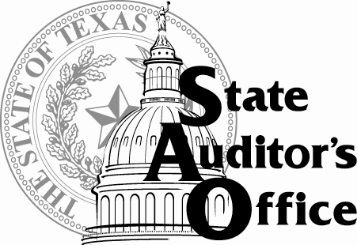
THE STATE AUDITOR’S OFFICE
Robert E. Johnson Building • 1501 North Congress Avenue
Mailing Address: P.O. Box 12067 • Austin, Texas 78711-2067
General Information (512) 936-9500 • FAX (512) 936-9400
WEB SITE http://www.sao.texas.gov/
APPLY http://www.sao.texas.gov/Careers/

JOB OPPORTUNITY

JOB POSTING NO. | AUD-1009
JOB TITLE | Auditor II-III
MONTHLY SALARY | Auditor II: $3,429.58 – $5,263.25/mo plus benefits  Auditor III: $3,918.08 – $6,215.00/mo plus benefits
POSTING DATE | March 10, 2022
CLOSING DATE | May 13, 2022
HIRE DATE | June 1, 2022
HOURS PER WEEK | 40; Willingness to travel up to 25% within Texas required.
LOCATION | Austin, Texas (No satellite offices.)
NO. OF OPENINGS | Multiple
GENERAL DESCRIPTION:
The successful applicant will perform professional auditing work for the State Auditor’s Office, the independent auditing organization of Texas state government. Auditors perform audit procedures, prepare audit documentation, reach conclusions based on audit evidence, and make recommendations to improve government operations. Work is conducted in accordance with generally accepted government auditing standards. We are seeking auditors able to conduct audit procedures (which may include IT audit procedures) on financial and/or performance audits of agencies, institutions of higher education, and other entities that receive state funding. Applicants must be willing to travel within Texas up to 25 percent of the time.
ESSENTIAL JOB FUNCTIONS:
- Assigned to financial and/or performance audits.
- Assesses risks, identifies internal controls, and develops and performs audit procedures.
- Conducts individual and group interviews, reviews client and staff documents, requests and analyzes client information, develops audit findings and conclusions, composes summary memos, and prepares audit documentation.
- Uses knowledge of appropriate audit standard and audit tools.
- Works within a team-based environment.
- Develops and maintains productive client and staff relationships.
- Safeguards sensitive and confidential information.
- May also be required to assess risks associated with information system/technology security, software, hardware, and application development; and to perform or assist in performing general and application control reviews of information systems.
MINIMUM QUALIFICATIONS:
Auditor II
Bachelor’s degree (copy of transcript requested upon interview) or Master’s degree in accounting, business administration, computer science, computer/management information systems or related fields. No experience necessary, but experience in auditing, information technology/systems auditing, financial analysis, accounting, or other relevant fields is preferred.

Auditor III
Bachelor’s degree (copy of transcript requested upon interview) or Master’s degree in accounting, business administration, computer science, computer/management information systems or related fields. 1 to 3 years’ experience in auditing, information technology/systems auditing, financial analysis, accounting, or other relevant fields is required. (Certification as a Certified Public Accountant (CPA), Certified Fraud Examiner (CFE), Certified Internal Auditor (CIA), Certified Information Systems Auditor (CISA) may substitute for experience.)
KNOWLEDGE, SKILLS, & ABILITIES:
- Knowledge of auditing standards (e.g., Government Auditing Standards, AICPA Statements on Auditing Standards).
- Knowledge of various audit methods.
- Knowledge of internal controls structures and assessment.
- Knowledge of financial accounting, including cost accounting.
- Knowledge of general business processes, such as budgeting, cash management, and procurement,
- Knowledge of information system controls, processes, and practices.
- Skill in gathering and analyzing information.
- Skill in using risk assessment techniques (identifying, measuring, and prioritizing risk).
- Skill in clear and concise verbal and written communication.
- Ability to prioritize and manage multiple priorities and tasks.
- Ability to perform data analysis using software applications (e.g., Excel, Access, Audit Command Language).
- Ability to establish and maintain effective working relationships with staff and clients.
PREFERRED QUALIFICATIONS:
Experience in public sector auditing (financial, performance, or information systems), Single Audit Act federal compliance auditing, cost accounting, budgeting in Texas government, or accounting/business processes. Desired certifications include: Working toward becoming or achieved designation as a Certified Public Accountant (CPA), Certified Internal Auditor (CIA), Certified Fraud Examiner (CFE), or Certified Information Systems Auditors (CISA).

The State Auditor’s Office is an equal opportunity employer and does not discriminate on the basis of race, color, religion, sex, national origin, age, or disability in employment or in the provision of services. Applicants should communicate requests for disability-related accommodations during the application process to our Human Resources Office.

